Title title tile title

Name1 Surname1[1],*, Name2 Surmane21, Name3 Surname3[2]

**Keywords**: keyword1, keyword2 (max. 5)

ABSTRACT

Abstract should be written clearly and in good English and do not exceed the imposed 4000-5000 characters’ length limit (as well as **no more than two A4 pages**).

Table 1. Example Table Title (Verdana, 10pt)

|  |  |  |
| --- | --- | --- |
|  | Parameter, Unit | Temperature, oC |
| Sample A | 100 | 0 |
| Sample B | 200 | 100 |

The 10 pt Verdana font should be used. Text should be justified, single-spaced. Margins should be set at 2.5 cm and the first line indent should be 0.75 cm. No lines between paragraphs. References (if used) should be numbered in square brackets. Please don’t use automatic numbering (both in the affiliation and references). The printed version of pictures will be black and white or gray-scale. Prepare your pictures with 300DPI resolution.

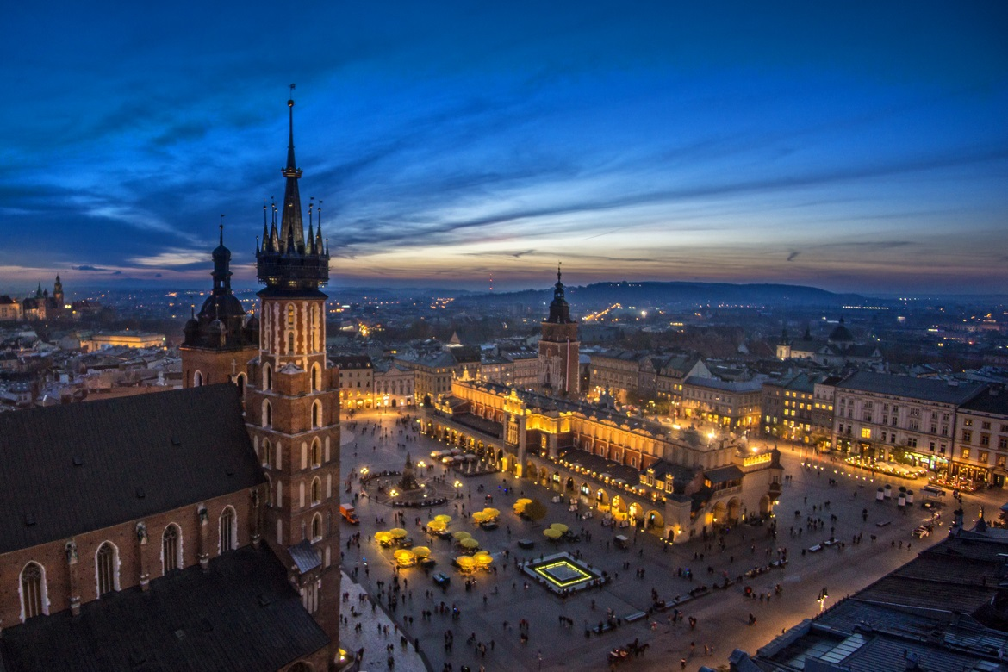  
Figure 1. Injector construction [5]

[1] S.I. Morehouse, R.S. Tung, Journal of Paleontology, 17 (1993) 198-209.

[2] T.V. Billoski, Introduction to Paleontology, 6th ed., Institutional Press, New York, 1992.

[3] M.T. Schwartz, T.V. Billoski, Greenhouse hypothesis: effect on dinosaur extinction, in: B.T. Jones, N.V. Lovecraft (Eds.) Extinction, Barnes and Ellis, New York, 1990,

[4] (accesed on: date) http://efe2024.agh.edu.pl (on-line)

1. Affilliation1
2. Affilliation2

   *corresponding author: email@email.email